**Building Custom Images Through Docker Server**

* **Creating docker images:**

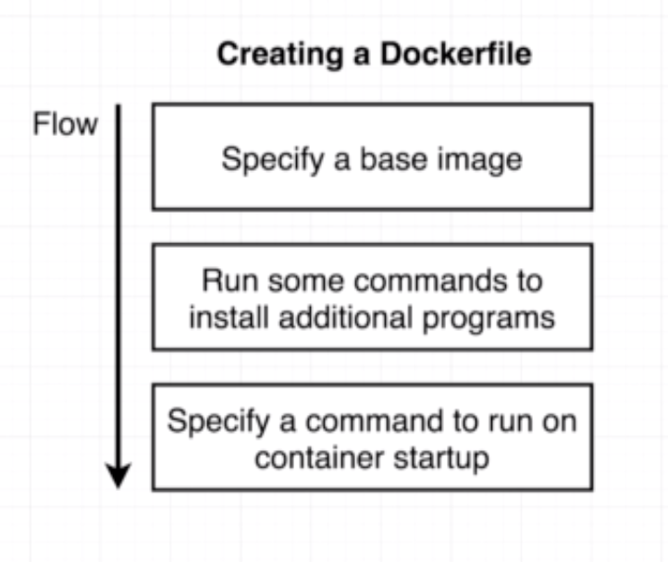

* **Building a docker file:**

Go to terminal in the working directory create a new directory named “redis-image”

Inside that director create a file named “Dockerfile” and add below lines of code.

FROM alpine

RUN apt add - -redis

CMD [“redis-server”]

Now run below command to build the image

docker build .

* **Dockerfile teardown:**

* **What’s a Base Image?**

* **The build process in detail:**

docker build .

build -> builds the image.

. -> Build context.

Logs of docker build command:

Sending build context to Docker daemon 2.048kB

Step 1/3 : FROM alpine

---> cdf98d1859c1

Step 2/3 : RUN apk add --update redis

---> Running in 63a0bca6887e

fetch http://dl-cdn.alpinelinux.org/alpine/v3.9/main/x86_64/APKINDEX.tar.gz

fetch http://dl-cdn.alpinelinux.org/alpine/v3.9/community/x86_64/APKINDEX.tar.gz

(1/1) Installing redis (4.0.14-r0)

Executing redis-4.0.14-r0.pre-install

Executing redis-4.0.14-r0.post-install

Executing busybox-1.29.3-r10.trigger

OK: 7 MiB in 15 packages

Removing intermediate container 63a0bca6887e

---> e0af19647877

Step 3/3 : CMD ["redis-server"]

---> Running in 3f1d5dc2e337

Removing intermediate container 3f1d5dc2e337

---> 1606babcf403

Successfully built 1606babcf403

* **Tagging an image:**

docker build -t dspandiyan/redis:latest .

* **Manual Image creation:**

Here we are going to create the redis-server image we built previously using dockerfile manually.

Note: This feature is just for learning purpose, don’t use this on project.

Step1: docker run -it alpine sh

Step2: apk add - -update redis

Step3: Run on a separate terminal:

docker ps

docker commit -c ‘CMD [“redis-server”]’ container_id

Output will be the id of new image we built manually

Then run the newly created image as below.

docker run image_id